**Oracle Lab 8: Procedure - Function**

***Assoc. Prof. Dr. Nguyen Thai Nghe***

*Refer to this link* [*http://plsql-tutorial.com/plsql-procedures.htm*](http://plsql-tutorial.com/plsql-procedures.htm)

[*https://www.guru99.com/subprograms-procedures-functions-pl-sql.html*](https://www.guru99.com/subprograms-procedures-functions-pl-sql.html)

*for learning Procedure and Function.*

*Save to* ***StudentID-lab8****.sql*

**General Syntax to create a procedure is:**

CREATE [OR REPLACE] PROCEDURE proc_name [(list of parameters)]

IS

[Declaration section]

BEGIN

Execution section

[EXCEPTION

Exception section]

END;

### *Procedures: Passing Parameters*

*We can pass parameters to procedures in three ways.*

*1) IN-parameters*

*2) OUT-parameters*

*3) IN OUT-parameters*

**How to execute a Stored Procedure?**

There are two ways to execute a procedure.

1) From the SQL prompt.

EXECUTE [or EXEC] procedure_name;

2) Within another procedure – simply use the procedure name.

procedure_name;

**General Syntax to create a function is**

CREATE [OR REPLACE] FUNCTION function_name [(parameters)]

RETURN return_datatype

IS

Declaration_section

BEGIN

Execution_section

Return return_variable;

[EXCEPTION

exception section]

END;

**How to execute a PL/SQL Function?**

A function can be executed in the following ways.

1) Since a function returns a value we can assign it to a variable.

*variable_name := func_name;*

2) As a part of a SELECT statement

*SELECT func_name FROM dual;*

3) In a PL/SQL Statements like,

*dbms_output.put_line(func_name);*

This line displays the value returned by the function.

**Exercises (using Scott schema): Write procedures and functions. Test all of them.**

1. Write a procedure to update salary of an employee (given empno, new salary)

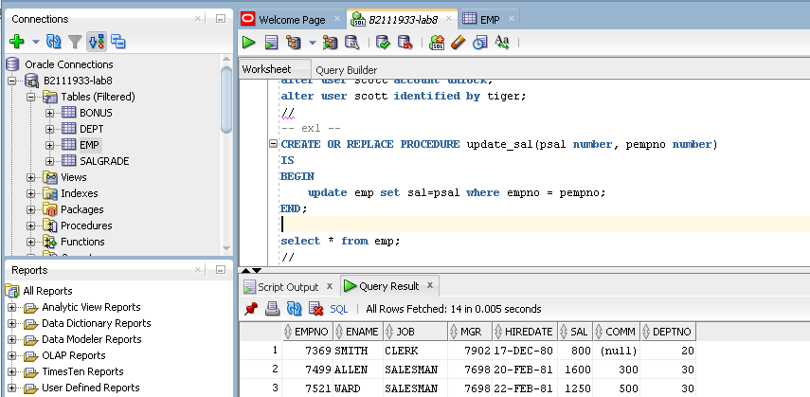

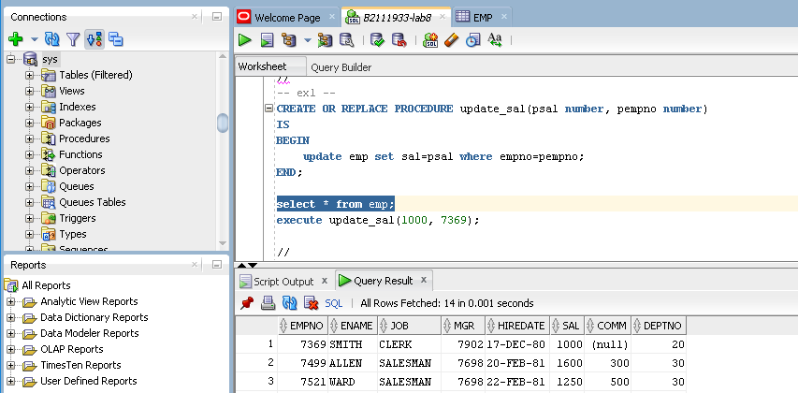

1. Write a procedure to update salary and comm of an employee (given empno, new salary, new comm)

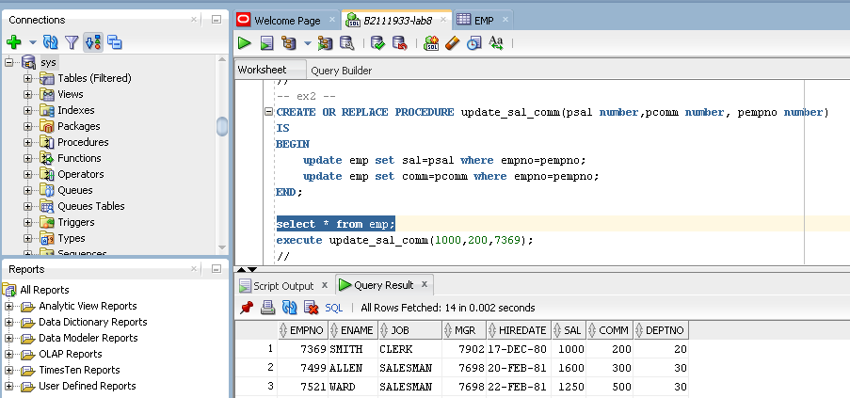

1. Write a procedure to delete an employee (given empno)

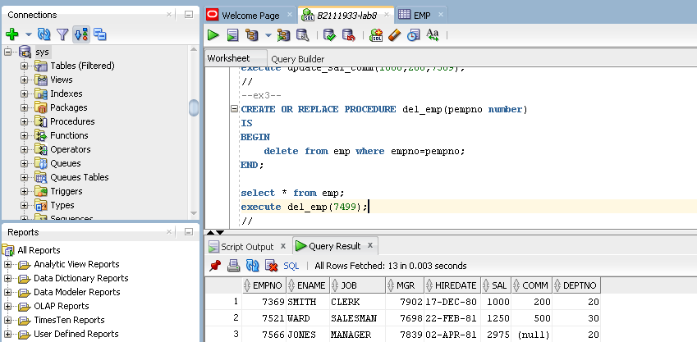

1. Write a procedure to add an employee

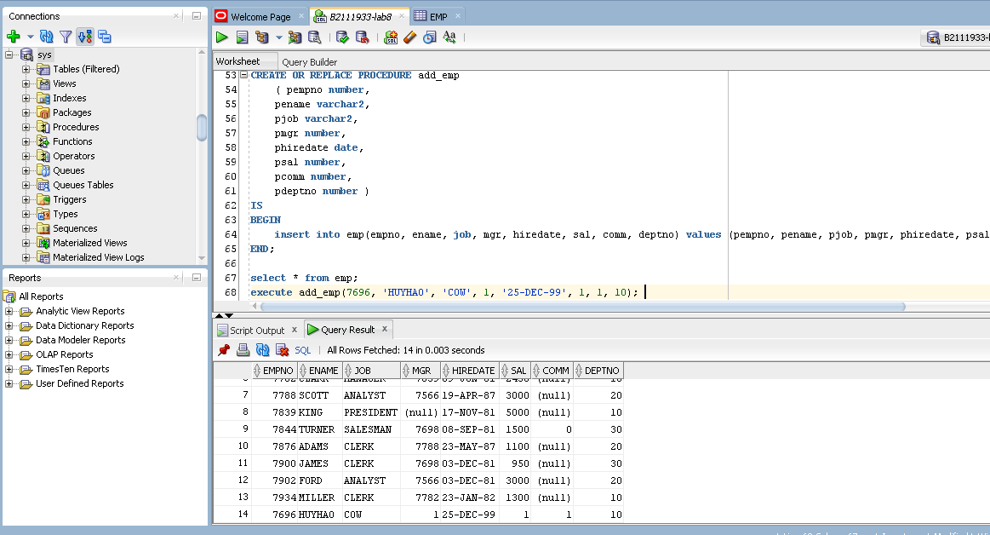

1. Write a procedure to increase salary of all employees in a department (given percentage of new salary, deptno)

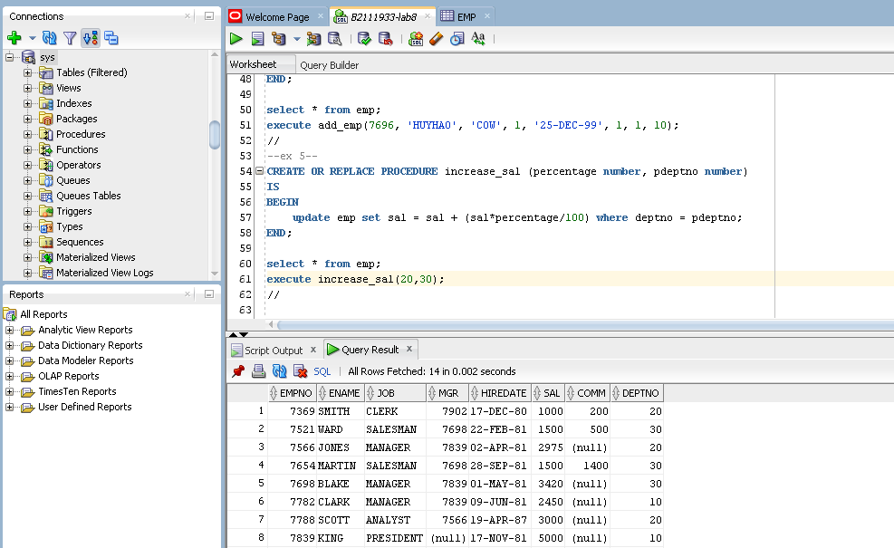

1. Write a function to return total salary of a given department number (test by getting deptno from the keyboard)

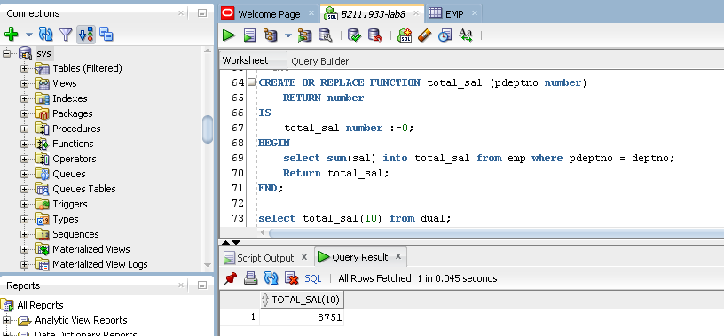

1. Write a function to return **name and job** of an employee (given empno)

